Warhol Superstars | Creative Brief

Mikki Janower

November Seventh, 2018

Project Overview

The goal of my project is not only to provide information about Warhol’s superstars, but also to serve as a highlight reel of the iconic media revolving around them. I want to bring attention to the roster of makers and thinkers who rarely get credited for their contributions to Warhol’s legendary Silver Factory.

Resources

<https://www.crfashionbook.com/culture/g22618718/andy-warhols-birthday-muses/>

<https://en.wikipedia.org/wiki/Warhol_superstars>

Lots of photographs available on Pinterest + Google Images as well!

Audience

I would direct this towards people who Instagram in front of Warhol’s soup cans: hip young creatives who will start to dress like Edie Sedgewick once they know she exists. This person probably has a Velvet Underground poster but has never heard their music. We need to *enlighten this person*.

Message

I’d like to focus on how their aesthetics left their mark on Warhol’s factory. Very few self-professed art and fashion aficionados understand that Warhol never operated alone; he was normally flanked by a squadron of superstars. They contributed to his work, and he to theirs, and their combined efforts helped establish the free-thinking culture of the 60s.

Tone

For tone, aim for edgy and nonchalant. This shouldn’t read like a textbook. I definitely want to convey how laid-back the environment was and how effortlessly the figures inspired the rest of the art world.

Visual Style

The site should look industrial; this means you can stay pretty minimal and let the media speak for itself, and the vibe will reflect pop art and the Readymades movement.

It might be fun to add in some messy elements, like misregistered duotones or transparent pngs of artists’ handwritten notes/poetry, or juxtapose Warhol’s work against a film photograph of the superstars who helped him with it. I don’t think you have to generate your own ornament, though; I think the Factory work can be the only real decoration on the page.

Visual References

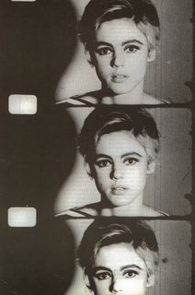

Warhol filmed *Screen Tests* of many

of his friends and superstars-some

very cool footage and stills were

generated. Edie Sedgewick shown above.

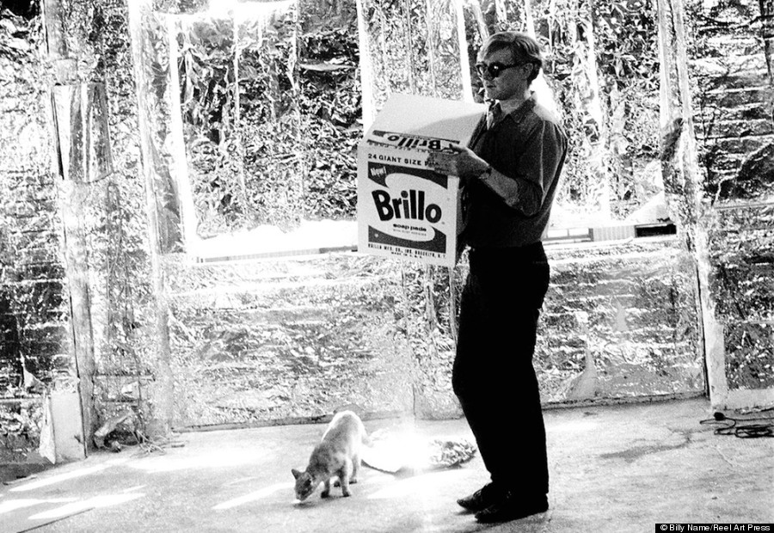

Warhol in his Silver Factory, which earned its name when a member of his entourage, extremely drugged and manic, covered the entire space with silver foil. Friends and superstars

would constantly walk into the space unannounced, and something new

was always in the works.

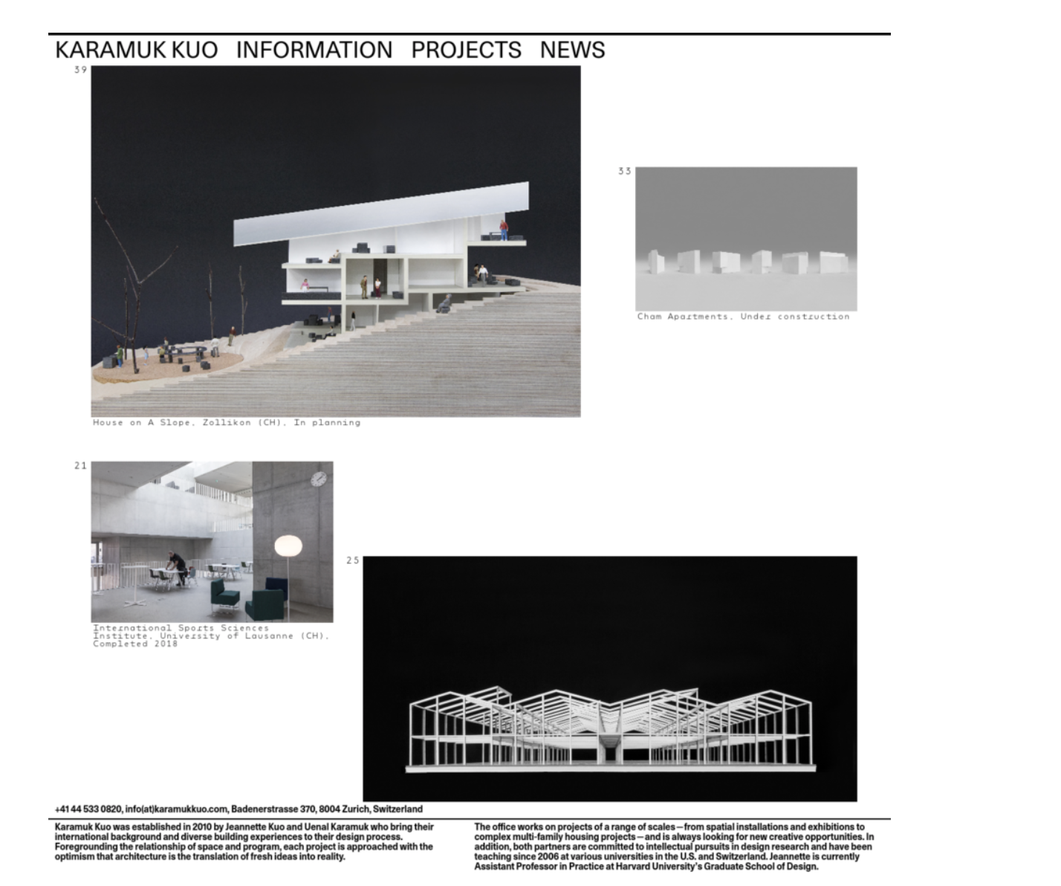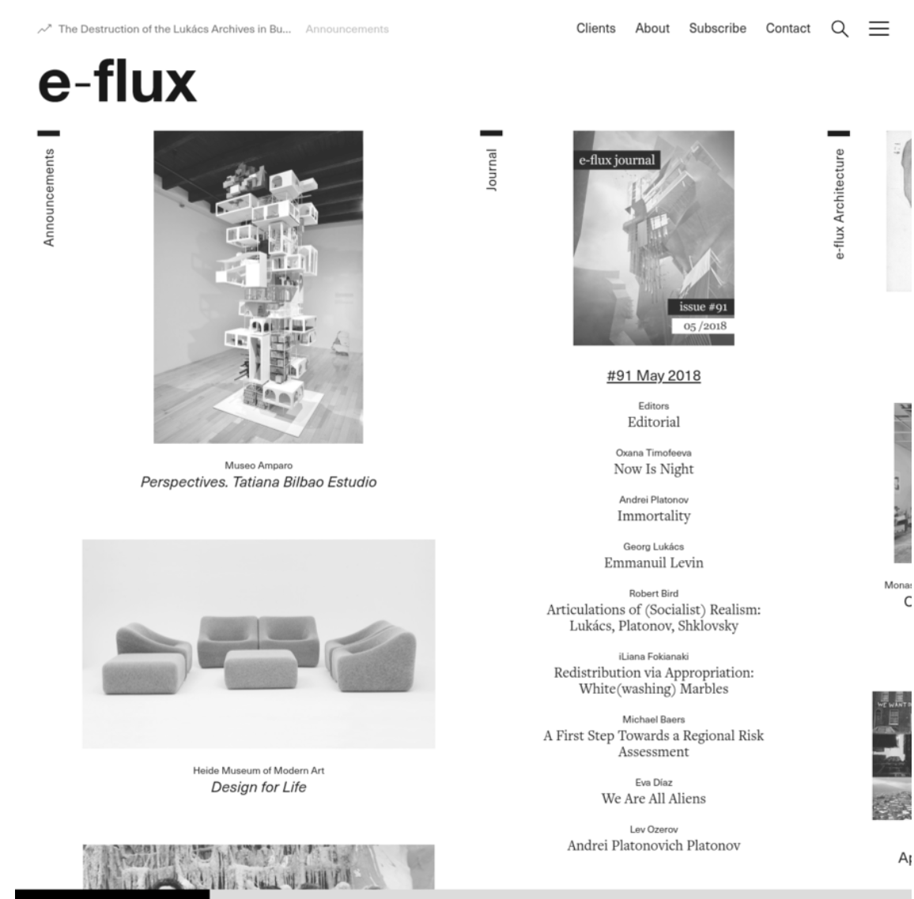

Here are two websites I really like that feel like they could fit the prompt. For my full repository of web design inspiration, visit <http://are.na/mikki-janower/web/1526181143>